**Incidents Management in ServiceNow**

**Document History**

|  |  |  |  |  |  |
| --- | --- | --- | --- | --- | --- |
| **Version** | **Release Date** | **Created By** | **Description of**  **Change** | **Genpact**  **Approval by** | **Customer**  **Approval by** |
| 1.0 |  |  |  |  |  |
|  |  |  |  |  |  |

**Terminology & Abbreviations used**

|  |  |
| --- | --- |
| Vendor / Supplier | Party who sells goods / provides services to **customer name** |
| AD |  |
| Goods | Products being provided drinks, food, non-food items |
| Store | The place of delivery of good by the vendor/Supplier |
| T-code | Transaction code in SAP |
| SAP | Business ERP |
| SAP R1P | SAP Module used for maintaining master data in Europe region |
| Maxi R | Tool used by the stores to upload details of Goods received |

**TABLE OF CONTENT**

1 Introduction 4

2 Overview 4

2.1 High Level Manual Process Description 4

2.2 Target Applications 4

2.3 Process Prerequisites 4

2.4 Definitions 5

3 Process Diagram - 5

4 Incident Management Process Description 7

5 Scheduling of Activities 7

6 User rights and access 7

# Introduction

This document provides a detailed and step by step understanding of “Incident creation in ServiceNow”. In this application, we can create/store list of service incidents in a web table format. First, we extract the top three incidents which exist in the web table incident list. Once we extract the incidents, that extracted information will be stored into a mapping excel sheet file. After that, will create some new incidents using those stored retrieved details from the mapping file. Then we extract the incident web table completely, and we segregate the incident based on status and will be stored in each excel sheet accordingly.

# Overview

## High Level Manual Process Description

1. Open the “Services.com” site.
2. Login into the services application.
3. Find the Incidents, in the search tab
4. Retrieve the top three incidents information and store it into a excel sheet and upload the same excel file details to the server.
5. Get the incidents details mapping file from the server and create new incidents, using mapping file details.
6. New incidents will be included into Incidents web table.
7. Extract the Incidents web table and store the web table into excel sheet.
8. Sort the incidents based on Status.
9. Create different excel sheet and store all the incidents from the web table, based on each individual status and store it
10. Once we segregated the incidents, upload all the output files into server.

## Target Applications

The following applications / systems are necessary to have access to, in order to perform the Incident management

1. Microsoft Outlook
2. Microsoft Excel
3. Internet Explorer
4. Services Now application
5. FTP Server

## Process Prerequisites

1. Access to ServiceNow Application
2. Access to Microsoft applications – Excel and Outlook
3. Access to FTP Server

## Definitions

1. **Vendor**

The ‘vendor’ is a party who is responsible for providing goods and services to the buyer. In this document, vendor refers to the businesses / service providers in the market who provide goods, utilities and other services to Delhaize.

# Process Diagram -

Below is the high level process flow showing step by step movement of account creation request in the system

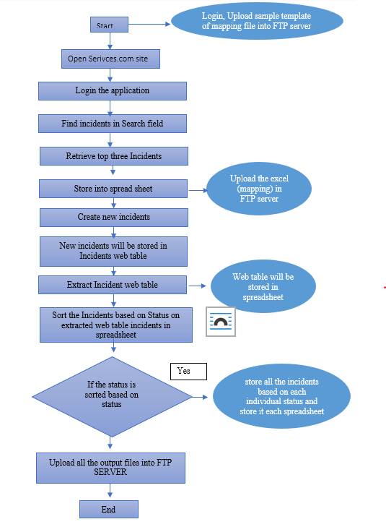

# Incident Management Process Description

Steps required to be followed for Incident Management:

1. Launch the Service.com web application through IE browser
2. Login into the Services application using the username and password
3. Once the application is launched, open the incidents.
4. To open incidents, in search field, find the incidents option, once the field are suggestion, click on incidents.
5. The Incidents web table will be shown, and it contains all the list of incidents will be present.
6. Retrieve top three incidents details and store it into the excel file (mapping file).
7. Login FTP/SFTP server with the admin credentials.
8. Then keep the mapping files and required templates into FTP server.
9. Create new incidents using the mapping files which contains all the incidents details (Download the mapping files from FTP server).
10. The newly created incidents will be included in the Incident web table.
11. Extract the Incident web table and store into the excel file.
12. Sort the incidents based on Status.
13. Create different excel sheet and store all the incidents from the web table, based on each individual status and store it
14. Once we segregated the incidents, upload all the output files into server.
15. Send the output files as attachment in the email to appropriate person.

# Scheduling of Activities

The frequency of “Incident Management” is based on requirement or any incidents occurred at that time we required to create an incident. Its frequencies are need basis in the services applications or user requirements.

# User rights and access

The FTP/SFTP server access is required to store the templates, mapping files and output files. Credentials required to login the services applications and additionally we need basic access for the Microsoft applications like excel and outlook to store incident details and send emails accordingly.

Start

End

Upload all the output files into FTP SERVER

Yes

If the status is sorted based on status

Open Serivces.com site

Sort the Incidents based on Status on extracted web table incidents in spreadsheet

Extract Incident web table

New incidents will be stored in Incidents web table

Create new incidents

Store into spread sheet

Retrieve top three Incidents

Find incidents in Search field

Login the application

End

No

Yes

Upload all the output files into FTP SERVER

store incidents based on each individual status and each spreadsheet

If the status is sorted based on status

Create new incidents

Sort the Incidents based on Status on extracted web table incidents in spreadsheet

Extract Incident web table

New incidents will be stored in Incidents web table

Start

Store into spread sheet

Retrieve top three Incidents

Find incidents in Search field

Login application

Open Serivces.com site